= PROJECTS

1. LMS (Learning Management System)

2. Test-Assessment System

= LMS Tab Required

1. Home
2. Curriculum
3. Student Profile
4. Test Assessment
5. Job assistance
6. Key Features
7. Design Database Schema
8. **Optional Advanced**
9. Logout

1. Home Tab

* Courses Offered
* Ongoing Courses
* Upcoming Courses
* Certificates
* Quick Notification
* Student Profile

1. Curriculum Tab

* Course Overview
* Modules
* Lessons
* Sub-Lessons/Topics
* Assessments

iii) Student Profile Tab Required

* Basic (Name, IIG ID, DOB, Email, Contact Number, WhatsApp Contact Number, GENDER)
* Academic ( 10th % , 10 School Name , 10 Pass out year , 12th % , School Name , 12 Pass out year , Graduation Complete year)
* Document ( 10th Mark Sheet , 12th Mark Sheet , Govt ID , Graduation Certificate)
* Others (Current Location (state , city), Github Profile , LinkedIn Profile , Preferred Job Location , Training and Placement contact)

iv) Job assistance tab required:

* Internship & Apprenticeship Opportunities
* Career Counseling & Mentoring
* Interview Preparation Tools
* Networking Opportunities
* Skill Verification & Certifications

v) Resume Tab Required

* Create Resume ( )
* My Resume

vi) Key Features tab required:

* User Registration and Profiles
* Course Creation and Management
* Provide tools for instructors to create and organize courses
* Learning Path and Course Enrollment
* Content Delivery
* Quizzes and Assignments
* Discussion Forums
* Reporting and Analytics
* Notifications and Alerts

vii) Design database schema tab required:

* Users
* Courses
* Enrollments
* Progress

viii) **Optional Advanced tab required:**

* Gamification
* AI Integration
* Video Conferencing
* Courses Offered :
* **Courses Offered** in an LMS refers to the various learning programs or classes available to students, covering different subjects and skill levels.
* These courses provide structured content, assessments, and learning resources designed to help learners achieve specific educational goals.
  + Java Full-Stack Development
  + MERN-Stack Development
  + Python
  + Data Science
  + Cyber Security
  + AI & ML
  + Block Chain Developments
* Ongoing Courses :
* **Ongoing Courses** are the courses that learners are currently enrolled in and actively participating in. These courses.
* These courses have started but have not yet been completed, with learners progressing through the content and assessments.
* Java Full-Stack Development
* MERN-Stack Development
* Python-Django Stack Development
* Upcoming Courses :
* **Upcoming Courses** are courses that are scheduled to start in the future but are not yet available for enrollment.
* These courses offer learners the opportunity to plan and prepare ahead for upcoming learning opportunities.
  + Cyber Security
  + Block Chain Development
  + Data Science
  + AI & ML
* Certificates :
  + **Certificates** are official documents awarded to learners upon successful completion of a course or program, validating their achievements.
  + These certificates often include details like course name, completion date, and the learner's performance.

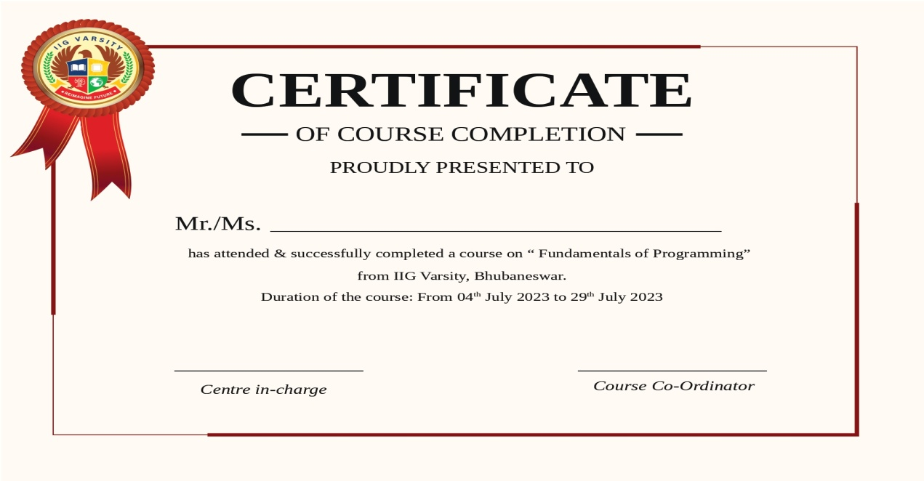

* **Quick Notification :**
* **Quick Notifications** are brief alerts or messages sent to learners or administrators to keep them informed about important updates or deadlines.
* These notifications can include reminders, announcements, or new course availability.
* Test Evaluation Event
* Debate Event
* **Student Profile :**
  + **Student Profile** is a personalized page that contains a learner's details, such as their name, enrolled courses, progress, and achievements.
  + It serves as a dashboard for tracking learning activity, performance, and upcoming goals.
* **Course Overview :**
* A course overview provides a brief summary of the course content, objectives, and key topics to be covered.
* It outlines the skills and knowledge students will gain upon completion.
  + - Purpose and Introduction:

The overview introduces the main idea of the course and why students should take it.

* + - Topics Covered:

It outlines the main topics or concepts that the course will cover.

* + - **Learning Outcomes**:

It describes the skills and knowledge students will gain by completing the course.

* + - **Course Structure:**

It can provide information about the course's organization, modules, or units.

* + - **Requirements:**

It may include information about prerequisites, assignments, or assessments.

* + - **Instructor Information:**

It can also include information about the instructor and their contact information.

* + - **Benefits:**

The overview should highlight the benefits of taking the course, addressing student needs and offering solutions.

* + - **Value Proposition:**

It should outline the course's value proposition, making it clear why students should enroll.

* Modules :
* Modules are distinct units of a course, each focusing on a specific topic or skill.
* They are designed to break down the learning process into manageable sections for better understanding and progression.
* Lessons :
* Lessons are individual learning sessions within a module, focusing on specific concepts or skills.
* They include activities, examples, and assessments to reinforce the material being taught.
* **Lesson Title**

A clear and concise title that reflects the main topic or skill the lesson covers.

Example: "Introduction to Java Data Types" or "Understanding HTML Forms".

* **Lesson Overview or Introduction**

A brief description of what the lesson will cover, its objectives, and why the topic is important.

Example: "In this lesson, you will learn about different data types in Java and how to use them in your programs."

* **Learning Objectives**

Clearly defined goals or outcomes that the student should achieve by the end of the lesson.

Example: "By the end of this lesson, you will be able to identify different data types in Java and use them in a program."

* Sub-Lessons/Topics :
* Sub-lessons or topics are smaller, focused segments within a lesson that break down specific aspects of the content.
* They provide detailed insights and help deepen understanding of the broader lesson material.
* **Title of Sub-Lesson/Topic:**
* **Clear and Concise Title:** The title should be direct and give learners an idea of what the sub-lesson or topic will cover. It should reflect a particular aspect of the broader lesson.
* **Example:** "Understanding Variables in Java" or "Introduction to Python Data Types"
* **Introduction/Overview:**
* **Purpose of the Sub-Lesson:** Provide a short introduction explaining the **goal** of the sub-lesson and its relevance to the broader lesson. This helps students understand why the topic is important.
* **Example:** "In this sub-lesson, we will focus on understanding the different data types in Python and how to declare variables."
* **Key Concepts/Definitions:**
* **Definitions:** Clearly define key terms that students need to understand the topic. This helps with building a strong foundation for more complex ideas.
* **Key Concepts:** Introduce the main concepts and ideas that will be covered in the sub-lesson.
* **Example:**
* **Variable:** A storage location in a computer’s memory with a specific data type that holds a value.
* **Data Type:** A classification of data that tells the compiler or interpreter how the programmer intends to use the data.
* **Detailed Content Explanation:**
* **Break Down the Topic:** Explain the topic in detail. This section should contain **step-by-step explanations** or **in-depth analysis**.Use **simple language** and **examples** to clarify the topic.
* **Example:** "In Java, variables are containers used to store data. Each variable has a specific data type, which determines the type of data it can store (e.g., int, float, String)."
* **Examples and Illustrations:**

**Provide Concrete Examples:** Include practical examples that demonstrate the concept in action. Real-world examples or code snippets work well in technical subjects.Use **diagrams** or **visual aids** if necessary to clarify complex ideas.

* Assessments :
* Assessments are tools used to evaluate a student's understanding and mastery of the course material.
* They can include quizzes, tests, assignments, or projects to measure progress and learning outcomes.
* **Self-Assessments**: Students assess their own progress, reflect on their learning, and identify areas for improvement. This encourages met cognition and personal responsibility for learning.
* **Formative Assessments**: These are ongoing assessments that provide feedback during the learning process (e.g., short quizzes, class discussions, or homework assignments) to help guide further learning.
* **Summative Assessments**: These are final evaluations used to assess the overall learning at the end of an instructional period, such as final exams or final projects.
* **Performance-Based Assessments**: Students demonstrate their skills through real-world tasks or simulations that require them to apply knowledge practically.
* Internship & Apprenticeship Opportunities :
* Assessments are methods used to gauge students' knowledge, skills, and progress.
* They help identify strengths, areas for improvement, and ensure learning objectives are met.
* **Skill Development**: These opportunities help students develop both technical skills (specific to their field) and soft skills (communication, teamwork, problem-solving) that are critical in the workplace.
* **Professional Networking**: Internships and apprenticeships often allow students to build connections with professionals in the industry, which can lead to mentorship opportunities, job offers, or valuable industry insights.
* **Transition to Employment**: Internships and apprenticeships serve as a bridge to full-time employment. Many employers hire interns and apprentices as permanent employees after graduation due to the students' familiarity with the company and their work.
* **Feedback and Development**: These opportunities provide a platform for students to receive feedback on their performance from experienced professionals, helping them grow and refine their skills in real-world contexts.

* Career Counseling & Mentoring :
* Career counseling and mentoring provide guidance to students or professionals in making informed career decisions.
* They offer support, advice, and mentorship to help individuals navigate career paths and achieve their goals.
* **Career Exploration**: Students can explore different career paths and industries through internships and apprenticeships, allowing them to determine if a specific field or role aligns with their interests and career goals.
* **Personalized Career Guidance**: Career counseling provides individualized advice based on a person’s strengths, interests, skills, and values. Counselors help identify potential career options that align with personal goals, academic background, and passions.
* **Goal Setting and Planning**: Counselors and mentors help individuals set short- and long-term career goals, develop a clear action plan, and track progress over time. This can include identifying key milestones, required qualifications, and potential obstacles.
* **Continuous Career Development**: Career counseling and mentoring don't end once a job is secured. They support lifelong career growth, guiding individuals through promotions, career transitions, or even career changes as they evolve professionally.
* Interview Preparation Tools :
* Interview preparation tools are resources designed to help individuals practice and refine their interview skills.
* They typically include mock interviews, common questions, tips, and feedback to boost confidence and performance.
* **Industry-Specific Resources**:

Some tools are tailored to specific industries or job roles, providing more relevant questions, insights, and preparation material based on the job you're applying for.

* **Video Simulations**:

Mock interviews with video simulations allow individuals to see how they perform in a live setting, including verbal and non-verbal communication.

* **Time Management Practice**:

Timed practice sessions help candidates refine their ability to answer questions succinctly within a specific timeframe, which is important for real-world interviews.

* Networking Opportunities:
* Networking opportunities provide a platform for individuals to connect with professionals, peer, and mentors in their field.
* These interactions help build relationships, exchange knowledge, and create career advancement opportunities.
* **Networking and Job Search Strategies**: Mentors and counselors can help individuals expand their professional network by suggesting relevant industry events, alumni groups, and networking strategies. They may also provide leads on job opportunities or internships.
* **Access to Industry Experts**:

Networking opportunities allow individuals to engage with experienced professionals and industry leaders, offering valuable insights and guidance that can shape career development.

* **Collaborative Projects**:

Networking opens doors to collaboration opportunities with peers and professionals on projects or initiatives, enhancing skill sets and building a strong professional portfolio.

* **Online Networking Platforms**:

Platforms like LinkedIn, professional forums, and social media groups allow individuals to connect with others, engage in discussions, and find networking opportunities from anywhere in the world.

* Skill Verification & Certifications:
* Skill verification ensures that an individual has the necessary expertise, often through assessments or tests.
* Certifications validate these skills through formal recognition, often awarded by accredited organizations.
* Create Resume:
* Creating a resume involves summarizing your professional experience, skills, and education in a clear and concise format.
* It highlights your qualifications to potential employers for job opportunities.
* My Resume :
* Your resume is a personal document that showcases your work experience, education, skills, and accomplishments.
* It serves as a tool to present your qualifications to potential employers.
* User Registration and Profiles :
* User registration involves creating an account by providing personal details for access to a system or platform.
* Profiles store and display the user's information, preferences, and activity within that platform.
* Course Creation and Management:
* Course creation and management involve designing, organizing, and delivering educational content, while overseeing enrollment, progress tracking, and course updates.
* It ensures a structured learning experience for students and efficient administration for instructors.
* Provide tools for instructors to create and organize courses :
* Add multimedia content like videos, PDFs, presentations, and quizzes.
* Allow instructors to set learning paths, modules, and lessons.
* **Multimedia Content Integration:**

Instructors can **embed a variety of media types**, such as **videos, PDFs, interactive presentations**, and **audio files**, making the learning experience more engaging and accessible.

The ability to **create quizzes, surveys, and assignments** can help assess learners' understanding and provide instant feedback.

**Interactive elements** like **discussion forums**, **polls**, or **live chat** can be added to enhance student participation and collaboration.

* Learning Path and Course Enrollment :
* Learning paths guide students through a structured sequence of courses to achieve specific learning goals.
* Course enrollment allows students to register and participate in these courses, tracking their progress along the way.
* **Learning Path:**

**Learning paths** provide students with a clear roadmap, ensuring they follow a **structured progression** of courses or modules that build upon each other.Paths can be tailored to different **skill levels**, such as beginner, intermediate, or advanced, ensuring students receive content that is appropriate for their current expertise.

* **Course Enrollment:**

**Course enrollment** allows students to register for individual courses or a set of courses within a learning path, making it easier for them to access content and track progress.

**Enrollment management** features enable instructors or administrators to monitor student participation, manage waitlists, and handle course capacity.

s

* Content Delivery :
* Content delivery refers to the methods and platforms used to present educational materials to students, such as videos, readings, and interactive activities.
* It ensures that learners can access and engage with the course material effectively.
* Quizzes and Assignments :
* Quizzes and assignments are assessments designed to evaluate students' understanding and progress throughout the course.
* They provide opportunities for learners to demonstrate knowledge and for instructors to give feedback on performance.
* Discussion Forums :
* Discussion forums are online spaces where students can engage in conversations, ask questions, and share insights related to course topics.
* They foster collaboration, critical thinking, and peer-to-peer learning.
* Reporting and Analytics :
* Reporting and analytics involve tracking and analyzing student performance, engagement, and progress throughout a course.
* This data helps instructors and administrators make informed decisions to improve learning outcomes and course effectiveness.

* Notifications and Alerts:
* Notifications are messages that inform users of important updates or actions, while alerts are urgent notifications that require immediate attention or response.
* Both help users stay informed and take necessary actions promptly.
* **Users :**
* Users are individuals who interact with a system, application, or platform to perform tasks or access information.
* They can be customers, clients, or internal participants in a service or software.
* **Courses :**
* Courses are structured learning programs designed to teach specific skills or knowledge in a particular subject.
* They typically include lessons, assignments, and assessments to guide learners through the material.
* **Enrollments :**
* Enrollments refer to the process of registering or signing up for a course, program, or event.
* It tracks the individuals who have officially joined to participate in a specific learning experience or activity.
* **Progress :**
* Progress refers to the advancement or completion of tasks, lessons, or goals within a course or activity.
* It tracks how far a learner has come in mastering the material or achieving the desired outcomes.
* **Gamification :**
* Gamification is the integration of game elements like rewards, points, and challenges into non-game contexts to engage and motivate users.
* It aims to enhance user experience and drive participation through fun, competition, and achievement.
* **AI Integration :**
* AI integration involves incorporating artificial intelligence technologies into systems or applications to enhance functionality and decision-making.
* It enables automation, personalization, and smarter user experiences through data analysis and machine learning.
* **Video Conferencing :**
* Video conferencing is a technology that allows users to communicate face-to-face remotely through video and audio over the internet.
* It enables virtual meetings, collaboration, and communication across distances.

Top of Form

Bottom of Form